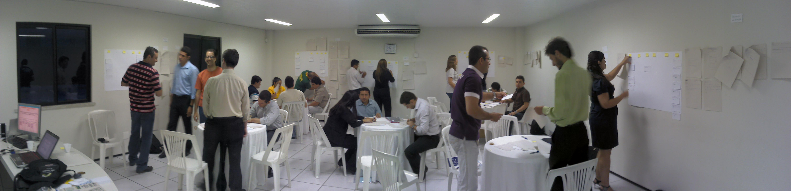
Kanban
Running The Flow Hour
Rodrigo Yoshima
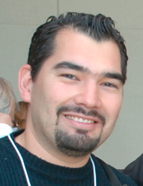
Good: Trainers talk less.
Better: Participants talk more.
Best: Participants DO more.

Dr. Sivasailam "Thiagi" Thiagarajan
”

A trainer who doesn't create his/her own
exercices and lessons is not a good trainer
but a copy/paste trainer.
Gendy Brown
“

About the Author:

Rodrigo Yoshima is a brazillian IT expert developing
computer systems since he was 12 years old.

For the last 16 years he is actively working with
complex systems for many companies and industries.

In 2005 he started to train and coach many teams
on good management and technical practices specially
with Agile Methods.

He owns Aspercom, a first-class company on IT
Training and consulting in Brazil.

Message for the Brazilian Software Industry:

Hope you shine on the worldwide market, find your own style, be creative and stop doing the same thing expecting different results. We can create software that changes the world.

Special thanks to Alisson Vale, our local world famous Kanban/Lean guru, for his knowledge and patience.

The Flow Hour

1. Short Introduction

When I was 18 I said: “I won't be a teacher. Never!”. Seriously. I simply hated to explain things and make them understand my points. I also hated school. School was a tedious place. Long-winded teachers, deeply bored students. Unfortunately most schools I know today follow the same pattern. I wished something different for my daughters.

Teaching people for real can be a hard experience. If you take it serious, teaching is one of the most challenging activities you will ever face. A classroom can be frightening like sharks on the prowl.

For the last 6 years I've been working as a trainer and coach here in Brazil, and since then I've been trying to promote a better learning experience to my apprentices by hands-on activities as close as possible to real business situations. This is one of Aspercom's values.

“The Flow Hour” is one of these activities that I'm glad to share with you. It's a dynamic and fun class activity that will help your apprentices to understand and feel some complex concepts around Lean and Kanban applied to computer software environments. “The Flow Hour” is quite new and truly can be expanded and improved, but I really believe that the best way to improve it is sharing it with you and many other trainers around the world.

2. History

The easiest way I've found to explain software development to my apprentices is to tell a story, create a situation and put them inside it. Every training program I develop has a problem, a customer and a target. My OOAD course has a hotel and a billing problem. My Scrum Workshop has a Yatching/Sailing Portal to become profitable. The Extreme Programming course, my favorite, we develop a microblog site like a corporate Twitter. This strategy is all about putting things on context and emulating real conditions with strong metaphors.

Do you know the Head First Series of books? They did an incredible job designing the visuals elements as part of the content to lightweight the reading. But, they use some poor and unreal examples. In the Head First Design Patterns they put something like Pizza.java or Car.java. It may sound clear to some people, but I find it harmful because it's unreal.

Many other trainers around the world run some activities using tennis balls, dices, coins and origami. I never liked these activities as good metaphors for software development. Being fun is not enough.

In 2009, influenced by Alisson Vale, I've started to study and experiment Kanban and Lean Science applied for software development, specially because the problems I've experienced with some teams running Scrum. By that time I've already trained more than 100 teams on Scrum and had deep experience coaching Agile on several companies.

In 2010 people started to ask more about Lean in Brazil and I was figuring out how to design a course program and its classroom activities that would explain Kanban. Something similar to the Yatching Portal activities I run on the Scrum course.

My initial vision for “The Flow Hour” had some requirements:

  - It should convince that we survive without iterations
  - To create some race, it should be a group activity
  - People's work must be a design activity (no dices please)
  - The knowledge should grow incrementally
  - It should not take too long

Using the experience I had creating other courses, “The Flow Hour” born as an intense hands-on activity targeted to immerse participants on a fictional project requiring swarming teamwork. I summary it as “from chaos to a more visible and predictable state using Kanban”.

In February 2010 I received a call from an IT manager in trouble, striving hard to run time-boxed sprints. Their IT department was a small group of around 20 developers responsible to deliver and maintain computer systems of several business units of Cvale, a big farmers' co-op with US$ 1.2 billion revenue.

Many IT managers ask me what is wrong with their Scrum. I met Cvale's guys in Palotina for a meeting and after a 2 hours chat and some process design we realized that due to the nature of their concurrent demand (remember, they were serving several business units) it was impossible to run time-boxed iterations efficiently. I suggested them to move to pull system with a more flexible release cadence using Kanban, promoting a more sustainable pace.

In that first visit to Palotina I had the opportunity to train more than 40 people on Kanban, including IT, operations, managers and business analysts. That was the first time I run “The Flow Hour” for real, and it run smoothly. Cool experience.

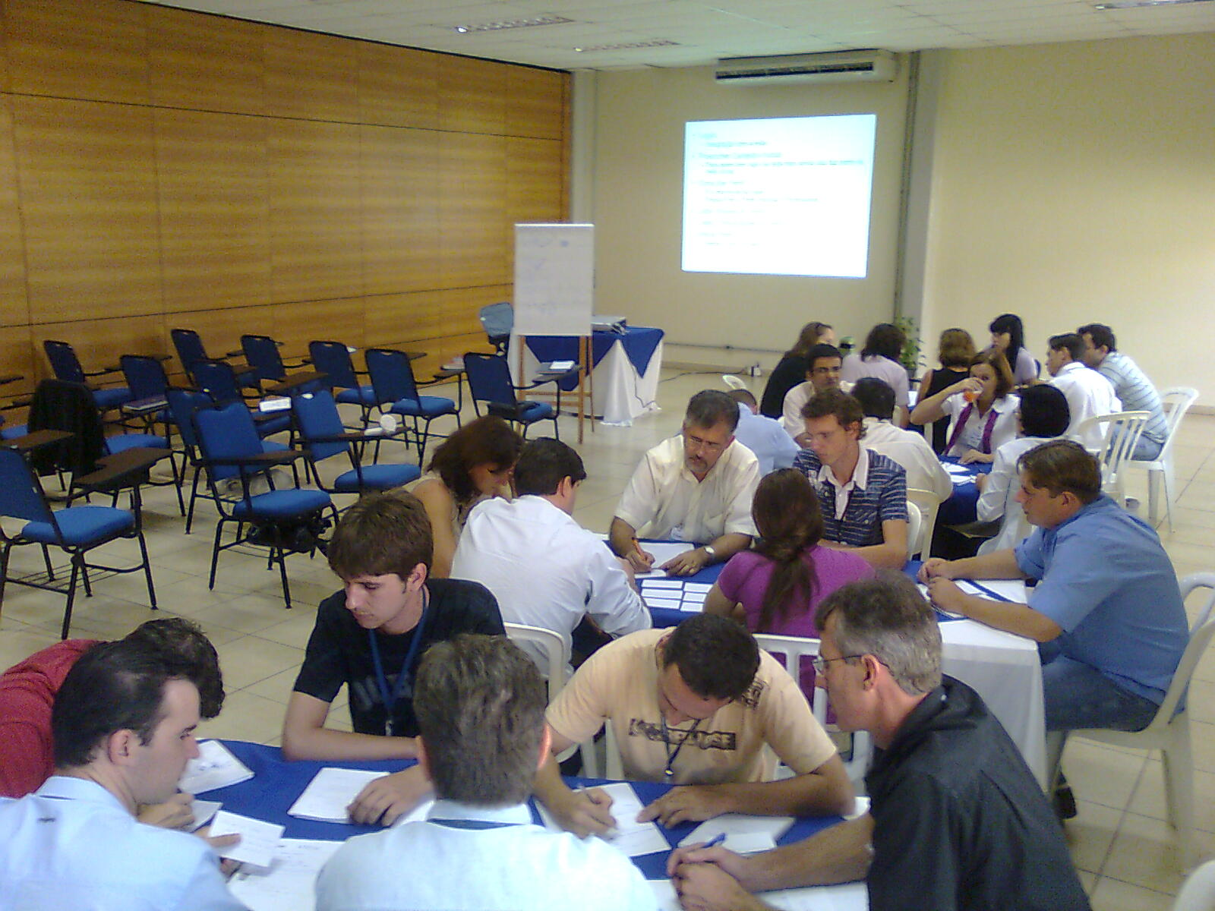
The Flow Hour at Cvale

Events and friends meetings gave me other opportunities to run and test some variations of “The Flow Hour” in 2010. Since January 2010 I was training and coaching Scrum and Kanban on a big insurance company in São Paulo (SulAmerica) and then many other customers asked for Kanban training. In August I decided to put a Kanban Workshop in our course list, but first, I asked Alisson Vale to evaluate it.

In November 2010 the “Maré de Agilidade”, a nice local event, was held in Fortaleza. This event gave me confidence to spread “The Flow Hour” nationwide. I invited Alisson to co-author an introductory Kanban course for the event. More than 25 people attended and we run the activity together with a nice feedback.

That was the first open Kanban for Software training run here in Brazil by brazilians. I'm glad that Alisson endorsed “The Flow Hour” activity. He had hundreds of fresh ideas for variations and improvements.
The Flow Hour at Maré de Agilidade

After the event I successfully run the activity with some minor updates. It's quite enlightening for those developers used to time-boxed iterative paradigm.

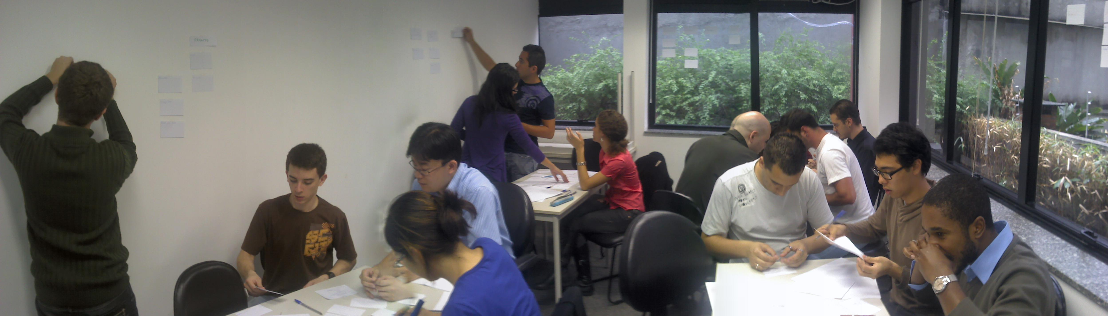
The Hour at Aurum Software – Help Desk, Services and Devs

The activity dynamic is easy, but in my experience some details are important. This document objective is to demonstrate how to run “The Flow Hour” and it's 5 rounds with no surprises. I hope you enjoy it.

3. Preparing for Action
To successfully run “The Flow Hour” all you need as a trainer is courage. The first time you run it you'll feel like the things are going out of control, but stay confident and trust your participants. They might feel confused in the beginning, specially on round 1 (also called the chaos). Sometimes the best way to promote some kind of self-organization is doing nothing. The message is: trust your apprentices. They will find the way by their-selves.

Before running the activity be warned that it takes more than 1 hour. Retrospective lengths varies a lot. The number of participants also take count. Usually our classes has 12-14 people. If your class is much bigger than that maybe you should call a friend to help you. As I mentioned before, Alisson and I run with 25 people, 5 groups. I don't think it would work without his help.

The room must have table and chairs for each group. Groups can be 4-7 people. Each group also must have a good wall space to put the Kanban board. The space will be quite noisy and people will need to walk around a lot. The slides are also important, so a projector is needed.

Other materials are listed below:

  - Sheets
  - Index Cards
  - Pens / Pencils
  - Post-its
  - Adhesive Tape

4. Explaining the Activity
First of all, read all the slides and try to run the activity by yourself. Simulate what will happen and make a script adapted to your style and course program. I usually start my course with “The Flow Hour”. It helps break the ice and gives me feedback of people's level. It also builds up a nice knowledge base for the rest of the course.

Note that the first slides explains barely enough to run the first round. Here is an important detail on the initial explaining: do not give participants to much information! Don't say we will break stories later, don't say we will design a Kanban, don't say anything! Just read the vision and make they feel free to try whatever each group decide. It can be messy.

You see that I use “round” for the activity periods. Note that it's not an iteration or sprint. Rounds just coordinate the activity to promote retrospectives and process improvements. It's mandatory that you don't put timers and don't say to the groups how long the rounds will take throughout the activity. If you say “this round will be 5 minutes long” it will create an instant mind association with “time-boxed” to the participants. Rounds don't have equal duration.

The prime objective of the activity is to create “iteration-less” coordination and flow. Like I said before, these details are important for the incremental knowledge construction “The Flow Hour” promotes.

Round 1 | Chaos with the big batch
Round 2 | Better visualization with Stories
Round 3 | First Kanban design
Round 4 | The user participates
Round 5 | Limit Work in Progress
Round 6 | Deliver / Flow

The first slides also explains the deliverables giving examples. It's quite simple to build them. Some companies I run the hour putting developers, testers and web-designers on each group.

4. In the beginning the chaos
The first round summary is: spread the chaos by making teams deal with a gigantic batch. Check the slide #8. That's all the information you will give. Just ask for the deliverables. Give them 8-12 minutes. Usually they will lose all this time discussing and doing Big-Design-Up-Front. Nothing is delivered. Some smart teams will break stories, but this is rare.

Remember, don't say how much it will last and don't put any timers ticking. When the round lasts promote a retrospective. Listen carefully what they say. It will give you an important big picture of the participants.

Ask them how they would deal with it on their companys. Ask them if all project features deliver the same business value. Ask if the user needs everything to go to production. Finally, ask if it would be a good idea to break this big batch on smaller ones if they don't come to this conclusion by their-selves. They should realize that batch size is important.

5. Round 2 – Smaller batches
The second round will give them a better visibility. Breaking the project on smaller parts and view it as incrementally deliverable is a skill that only few teams master. So this round 2 will be a kind of a-ha moment for many of them.

Probably you will see that many of them started the project doing some terrible choices. Really-really bad priorization. If it happens make them suffer the consequences. Remember that the policy is “Production ASAP”. If they fail on priorization they will learn a lesson and never forget it. Some groups finish stories on round 2. Unfortunately some stupid stories like “Login” or “Create Community”. Definitely not valuable ones and not deployable to production.

The second retrospective makes them feel much better and less chaotic. Ask them if they break stories or do something similar on their companies. Give focus asking if it improved the project visibility.

Some of you trainers might note that are too much stories on the slides. It's on purpose. By the round 4 or 5 you can say that many of the stories written are waste. Keep that in mind.

6. Round 3 – Visibility!
This round starts with teams designing a Kanban board. Give them 5 minutes for that and don't explain anything about how to do the design. See the process emergence! This is one of the coolest thing on this activity. Observe the participants and listen to them talking about their designs. You trainer will learn a lot!

On round 3 what you will demand for the groups is “As a customer/user I wan't to see the project status on the board. I want to see the stories status”. The suggested board on the slide won't give them much information. Make them think.

One thing Alisson Vale observed when we run the activity together is that each board has a unique design. You will see some of them quite waterfall. Other boards are more Scrum like. Some of them don't make any sense. This freedom is important because many people today copy board designs from books and articles. Don't impose your board style. Let the group/team take their own decisions. They can refactor it on the next rounds.

This retrospective also asks about visibility. Ask them if the board represents the actual work. Ask if it helps the visibility and predictability.

- Round 4 – User takes part

The round 4 starts with a question: “Do you remember the In Production Asap policy? What is the objective? Big Bang delivery?” This round we change the policy to include the user. You trainer will play this role. Your job is to prioritize, solve any doubts and accept the stories checking deliverable's quality.

As the slides mention you are responsible to queue 2 stories at a time when teams have empty slots on the “Selected” stage. Someone in the team should go to your desk and ask “We have empty slots”. Then you go to the team just to prioritize and go back to your desk.

When you prioritize the focus is to get a set of stories that would be valuable on production. The first MMF would be “Create Profile, Login, Show Profile, Search Worker”. Deploy only things that makes sense. You can create your own priorities before the activity starts. The Corporate Social Network example gives a lot of room to adapt things on the fly when the teams go faster. You can suggest them to abandon stories if they prioritized badly on previous rounds.

The detail for this round is: be the bottleneck! Sit comfortably on your desk. Do one job at a time and make participants wait in line by the side of your desk to get your attention. It will drive them mad and some groups will start to cheat.

They will see the restriction and will try to fight it increasing the work in progress or will stop working. They will understand pull and bottlenecks just like they might experience on their companies. The board will show it clearly.

The retrospective starts ironically asking how did it go. They will scream “The customer is the bottleneck!”. You can ask them how it happens on their companies and how pull systems can help them. If some team trickily increased the work in progress ask them if it delivered any value. Ask what quality risks they would face if the user rejects everything.

On round 4 some teams could have some story set already accepted and if it is usable can go to production. Check it every time you validate a story.

- Round 5 – Limiting WIP
This round will give the teams a clearer vision of Kanban by limiting the work in progress to restore the flow and raise the system value. The limit will be set on the efforts of the development (see slide).

You need to suggest a limit for the teams or run more 2 or 3 round to make them experience what happens when a limit is changed. If you are short of time put a limit based on the number of people. Smaller limits will make them swarm on the same story. Bigger limits will not affect the work at all but less value will be delivered.

